Supplementary Information for

# Carbon embodied in the economies of China, the European Union, and the United States

Kehan Hea, Edgar G. Hertwicha,*

*a Center for Industrial Ecology, School of Forestry & Environmental Studies, Yale University, New Haven, CT 06520, USA*

*Contact email:* [*edgar.hertwich@yale.edu*](mailto:edgar.hertwich@yale.edu)

1. List of data included in EXIOBASE 3.3

IO.A - Inter-industry coefficients (direct requirements matrix)

IO.S - Stressor coefficients (primary and environmental inputs - direct requirements)

IO.Y - final demand, in block-diagonal layout. Use "sum(IO.Y,2)" to convert to vector.

IO.V - value add vector (note that some MRIOs have disaggregated VA)

IO.L - Leontief inverse (total requirements matrix)

IO.x - gross output

IO.Z - transactions matrix (IO.A*diag(IO.x))

IO.F - Absolute stressor requiremnts (IO.S*diag(IO.x))

IO.Fhh - A final-demand width x IO.S height block with direct emissions

1. Validation with World Bank emission intensities

To validate our results, we have cross-checked our emission intensities with those given by World Bank Data (WB). Because the data given by World Bank does not have high resolution for 7 or more sectors as our calculation, we have decreased our emission intensity resolutions to economies-specify level, and compared emission intensities obtained from EXIOBASE 3.3 with that of World Bank. The differences of every data pairs are calculated and plotted in Figure 1, in the form of both probability density function plot and box plot. It is shown that the median of differences in emission intensities is 0.0949 Kg CO2/US$, with upper and lower quartile located at 0.3671 Kg CO2/US$ and -0.0111 Kg CO2/US$ respectively. This suggests that our estimation of emission intensities from EXIOBASE 3.3 is slightly higher than World Bank data. In addition, the standard deviation of the differences is 0.7191 Kg CO2/US$ suggesting that there are some emission intensities calculated from EXIOBASE 3 that deviate significantly from World Bank data. A heat map analysis shows that larger deviation generally happens with developing economies, and increases as it moves back in time series. Heatmap of emission intensity differences between our calculated results and World Bank data is attached in Supplementary Information, EXIO_WB_diff.xlsx, for readers’ reference.

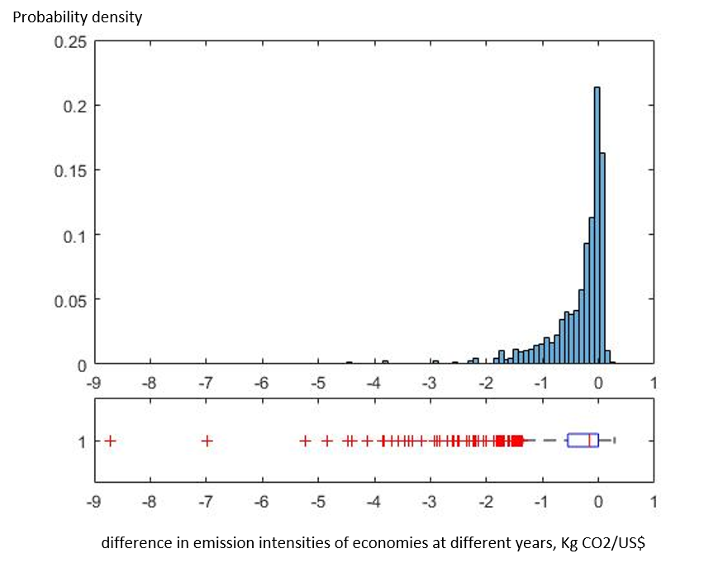

Figure 1 Examining accuracy of CBA emission intensity against World Bank data. The probability distribution plot and box plot are generated from differences of annual general emission intensities of economies. General emission intensities of Taiwan and 5 RoW continental regions, as well as emission intensities for year 2015 are removed as they are not available in World Bank database.

1. Closer inspection of CO2 emissions in China and comparison with CEEIO database

Instead of 7-sectorial resolution, we aggregate direct and indirect CO2 emissions in China into 17-sectors, and consolidated the analysis result into Figure 2. By increasing sector resolution for China to 17 sectors, we have discovered that the largest final CO2 emission in China comes from construction sector, ranging from 19% to 29%. On the side of intermediate CO2 emissions, metal, non-metal, petroleum, and chemical materials, as well as electricity, gas, and water, are the major contributor, ranging from 54% to 63% in total for the investigated years.

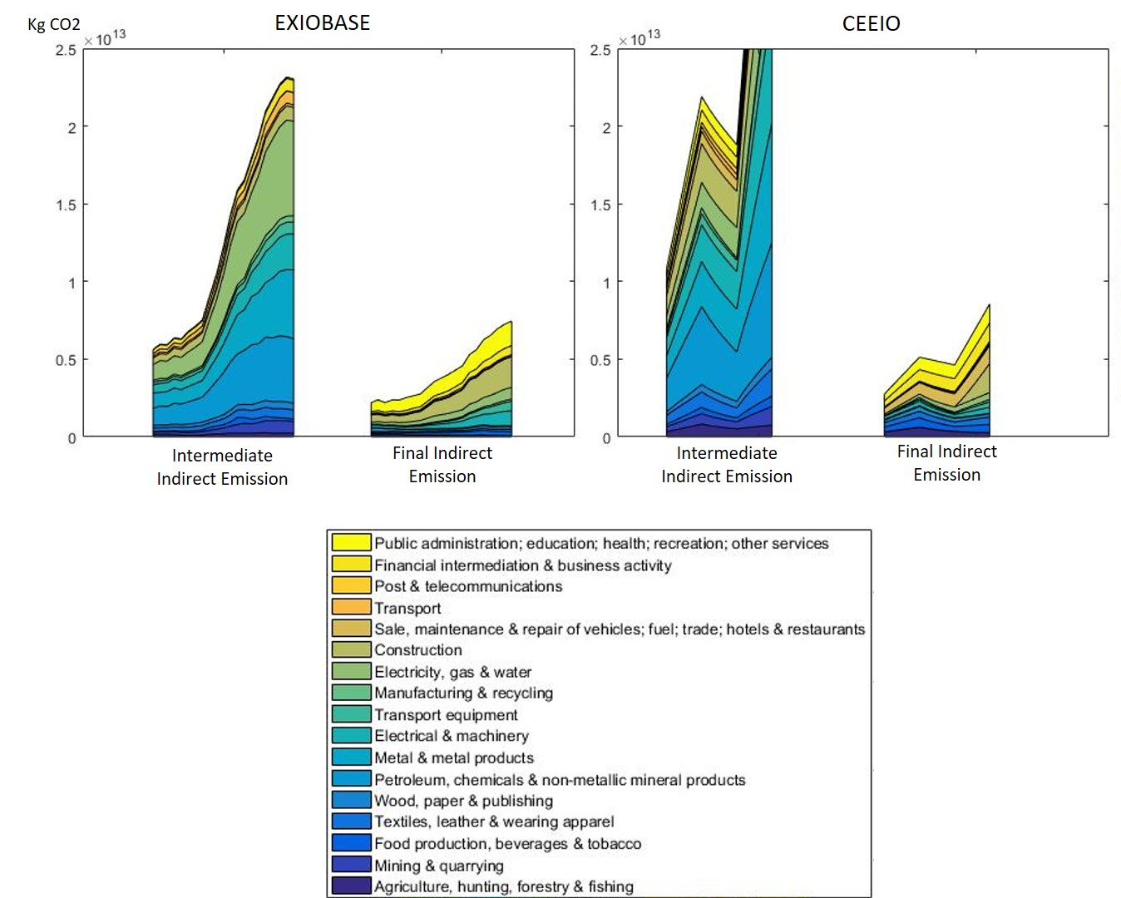

Figure 2 Indirect intermediate and final emissions of China, classified into 17 sectors, for year 1995 to 2015, compared with CEEIO database result.

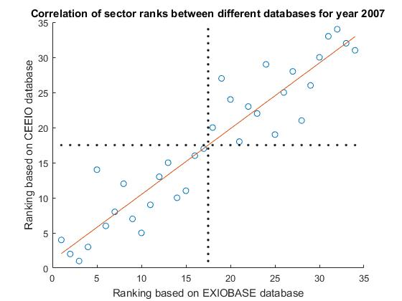

Figure 3 Correlation of sector ranks between EXIOBASE and CEEIO databases for year 2007

1. 200-item resolution full result for year 1997 and 2007 in .mat format

The full result in 200-item resolution from our calculation is as large as 5.5 gigabyte, making it impossible for us to share with readers by conventional means. Hence, we only presented intermediate and final indirect CO2 emission for 49 regions in .mat format, with a MetaData.mat file specifying the specific items and region names, in the supplementary information. If readers are interested in working with 200-item resolution results, please feel free to contact us. We will figure out a way to share it with you.